Northwest Wisconsin Career Prep Consortium
November 5, 2021 • 9:00 a.m. – 12:00 p.m. via Teams

Agenda Item | Responsible Party | Discussion/Information | Actions/Outcomes
9:00 Welcome and Check-Ins | Jeanne Germain
9:10 Northwood Tech Update  - Strategic Plan | Dr. John Will | John shared the Northwood Tech two-year strategic plan “Evolve XXIII”  (PowerPoint link) | https://www.northwoodtech.edu/about/Institutional-organization-and-Priorities/strategic-planning
Career Prep Updates
9:30 Career Prep Grant Update | Jeanne Germain | - Youth Fire Camp  - Educator Externships  - Build My Future Event  - Barron County Career Day  - Dual Credit Day  - Foster Youth Initiative | Career Prep will update the Northwood Tech short-term credentials brochure (Start College Now) and forward to high schools for spring.  Youth Fire Camp: Tim Hallberg sparked the idea and runs the camp, which is for youth interested in fire careers. This year (Aug 7-11 at Camp Phillips) there were 32 campers (ages 7th grade through senior) and approximately 25 staff and volunteers. It featured simulations, etc. and full gear is provided. It is Fire and EMS based and students leave with a CPR certification. Activities include putting out a car fire and working in confined spaces.  Educator Externships: High school teachers spend at least 40 hours at employer of choice over the summer learning real world applications to bring back to their classrooms. Dani Raether works with Jeanne Germain on this program.  Build My Future Event: Have not been able to have in-person events for students because of COVID. A virtual “Career Encounters” game was created so students could experience our programs online. With some fall events postponed, we  supported schools in attending outdoor events. i.e. “Build My Future WI” saw 800 students from 18 high schools in attendance. A grant paid for bus transportation and supplies for learning activities.  Dual Credit Day: This is an annual event to initiate articulations with high school teachers. Last year was a smaller virtual event as it was difficult for teachers to obtain subs. This year was virtual as well, with 19 teachers pursuing 44 courses (some being transfers but most were new courses added for next school year). We are receiving many requests for new articulations. It has been wrapped into our strategic plan, which is exciting.  Foster Youth Initiative: This is a specific fund that must be used to promote career readiness for fosters aging out of foster program. We plan to hold a “day in the life of a Northwood student” to be held on same day at all four campuses.
9:45 High School Academy &  Apprenticeship Updates | Eric Lockwood |  | Academies: Currently partnering with six school districts for six academies and exploring additional academies for the future.  Construction Essentials (9 credits – 3 courses) • technical diploma  u Amery, Hayward, Superior (20 students total)  Financial Services Customer Representative (14 credits – 7 courses)  u Hayward, Siren (8 students total) • technical diploma  Welding (10 credits – 4 courses) • two short term embedded technical diplomas  u New Richmond (15 students) – 5 other school districts involved  Registered Apprenticeships: A career path with 90 percent on the job training and 10 percent in classroom (strong rigor). Has expanded from construction and manufacturing to health care, finance, IT, agriculture. Valuable, high-quality training on the job site. Low cost, with a progressive wage scale. Wisconsin is the leader in the nation of registered apprenticeships!  There are seven different apprenticeships: Plumbing (which is the largest at 54 apprentices) through Ashland, New Richmond and Rice Lake; Maintenance Mechanic Millwright (16 apprentices) through Rice Lake; ABC Carpentry (13 apprentices) through New Richmond; Injection Mold Setup (12 apprentices); Cosmetology (7 apprentices) fully on line 2-year apprenticeship; Broadband Service Technician (2 apprentices) completely online. Electrical Construction (12 participants with 7 different contractors), is the newest apprenticeship with hybrid delivery (online with a portion of in person) – which can reach all 11 districts. Looking at areas to expand.  Looking at ways to tie the apprenticeships into youth apprenticeships for an “earn to learn” opportunity. Interested in finding ways to raise awareness. The grant can be used to promote this opportunity.
10:00 Future Grant Planning Activity | All |  | Jeanne began with a ‘Think outside the box activity’: “List as many uses of a spoon that you can.”  This led into our Future Grant Planning Activity, which utilized “Padlet” for committee members to share any and all ideas that fall under the grant guidelines.  https://padlet.com/jeannegermain1/amvrelkv7c4hmrsi  Below is the list of goals:  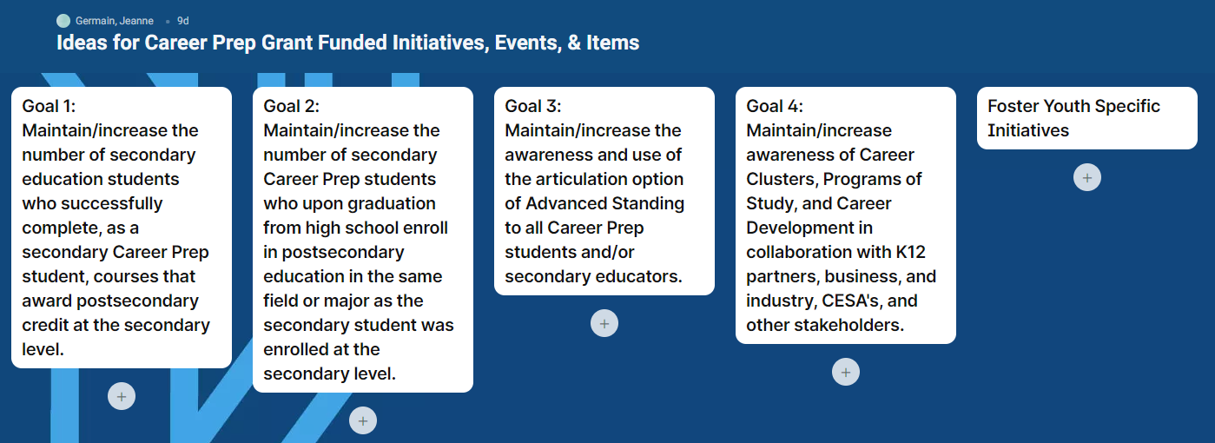  Visit the link above to see the many ideas/thoughts/challenges members entered, as well as those below:  • Informing parents seems to be one of our biggest struggles.  • Julie Thompson (Hayward HS) has sent info to families as to what the students have taken and how close they are to earning a tech diploma. A best practice for academy teachers?  • Amanda – CESA 12 suggests catching parents at parent/teacher conferences, by setting up a table and reaching out to other departments to add info – like with report cards, etc. Also add information into other HS mailings.  • Dede Maki suggests survey schools to learn how they get parents to respond.  Each district might have their own approach and group districts together that have similar approaches.  • Amanda Popovich believes we should utilize social media more.  Note: Padlet will continue to be open so you can add to it at any time or email Jeanne with additions.
10:30 Break | All
10:45 Agency Partner Updates | All |  | Pam Brunclik: Excited for expansion of FSCR Academy and interest in enrollments. Expanding IT Cyber and System Admin programs to Ashland and Superior – now fully available. Innovative Teaching and Learning Center: Goal is to optimize teaching and learning for all students and make it available to dual credit students as well, like a ‘one stop shop.’ Kudos to Christy Roshell – held first ever transfer fair where we invited 4-year partners and advertised to students. 21 4-year partners and 47 attendees, which was good for first event.  Megan Evans: Had our first Tuesday Tour, focusing on different career clusters. Nov 15 will highlight business programs and the business side of heath care. Tours are open to the public (attendees don’t have to be a HS student to attend). Has visited high schools to help guide students through FSA ID and provide the opportunity to apply with Northwood Tech. Representing WI School Counselor Association Annual Conference.  Kate Flug: Holding Career Day in November, and in the early planning stages for Tech and Industry mini program days. Campus is participating in the Christmas City of the North in Duluth where Northwood Tech semi will be driving in the parade with staff handing out goodies.  Melisa Hansen: Had a student participate in EMT experience which lead her to EMT through Start College Now. Have advisory board meetings for manufacturing and business – 5 business members in each area. Launching school-based enterprise to include manufacturing. College Fair is January 24 with over 70 colleges committed. Youth Apprenticeship – Lunch and Learns Nov 30 and Dec 1. Have 150 YAs and would like to hit 200.  Gayle Luebke: Casey and Gayle are relatively new and are in the process of studying their roles and creating an action plan, including what can be improved on and what the next steps are.  Dede Maki: Sponsoring our nontraditional occupations contest for the second year, which includes sending in a creative project that demonstrates why they pursued a non-trad occupation (based on gender). Have expanded resources for mental and physical health services to students – with virtual options. No cost to students. Positive feedback from students.  Jeff Muse: Trying to get people back to work from COVID situation. In youth area, having Crex Youth Camp again after recess. Coming back with bigger event and focusing on more career planning such as campfire career talks.  Amanda Popovich: New to CESA 12, so building relationships and learning what districts currently have available. Finding a lot of new teachers who just don’t know a lot about those areas. Making changes and adjustments – learning what’s available to them. Career Pathways may shift – thinking outside the box. November event coming up – partnering with Northwood Tech.  Danielle Raether: Regional Career Pathway – Out of 85 school districts we have over 90% of districts offering youth apprenticeships. Last year we rolled out pathways and have about 50 percent of school districts offering one or more of the pathways. Attacking finance education and training. Looking for needs of employers.  Christy Roshell: As of a month ago there were 66 transfer agreements with 28 different colleges. Highlight: Universal credit transfer agreement between tech system and UW system. We have 17 – there are 25 courses in total. We have 54 credits of our general studies that transfer directly to UW system.  Julie Thompson: It is a large challenge at the high school as we are face to face with no virtual option. Still have kids out for 10 days for positive test or close contact. It is a continuous struggle. Staff coverage is worse. It is a stressful time to be a teacher. Updated Quickbooks for dual credit agreement, and have added training for students to take the Intuit exam.  Melisa Weber: Holding a showcase for high school seniors in person on December 7. Inviting area high school seniors to check out Northwood Tech.  Erica Zerr: Worked with Megan recently to organize some Business and Industry Tours from our northern CESA 10 districts to visit Rice Lake and tour the campus as well as business industry. We will repeat for health Science and Construction pathways in the spring.
11:45 2022 Meeting Dates | Jeanne Germain |  | Winter • January: Virtual – Thursday, January 20th (morning 9-12)  Spring • April: Rice Lake campus – Thursday, April 28  Fall • November: Superior campus – Friday, Nov 4
12:00 Adjourn

